Samos Calling Ramadan Edition report , May 5 2021
No man is an island. (courtesy John Donne)

Look, we did it again!
During our Ramadan Edition some 15 people in Holland have donated 550 Euro to Samos Calling. M2M transferred the money to Eze Kay and the Team on Samos. They bought 44 slips of phone credit. And distributed them among us in the camp.

The purpose was to raise 500 Euro to satisfy all 57 on the original list.
The purpose was also to make sure that EK is not doing it all alone.
And our aim is to discover forms of artistic and activist collaborations.

- The 500 bucks was easy. Within a week we had 535 euro at M2M and 18nat Hulpkaravaan. The free publicity in the Nieuws BV did not bring new donations. No more donations came in after. Since the list is growing fast, now that word goes around in the camp we must ask ourselves if and how we continue fund raising. Thompson and Hermine seem to agree that we should give priority to people with 2 rejects. They get no money from the UN and are not free to move on.

- Eze Kay always worked together with his friend AY, who has a good Samsung S9 with hotspot. In the last month Thompson and Hermine have joined the team., They are both from Kameroon, Thompson English, Hermine French. They both played a very constructive role in clarifying situations (Thompson) and in relating with francophones, e.g. from Togo. Now that Eze K has his ID and money to buy a boat ticket, it is very good that we have a team to share the information and experience. This second transfer was realized direct and autonomously, without assistance from international volunteers. It cost an extra 30 Euro to transfer 550 euro (for 44 slips), but I can account for it, because of the fact that it was orthodox eastern (banks closed) and because Erika and Barbara were not available to check the list and observe the distribution.

- With Eze K we have a fantastic rap messenger, great to play him on the radio and here his live outbreaks in spoken word. Do we have more of these talents? Yes, AY and Thompson are good footballers, we have a musican/painter from Togo. We are looking to bring them into the radio. It would be great to find poets, reporters and new rappers. In Amsterdam we had contact with rapper Addi. More artists and activist could be engaged.

Daniel from Iran has joined the team, thanks to Eze K, who shared hos credit with him.

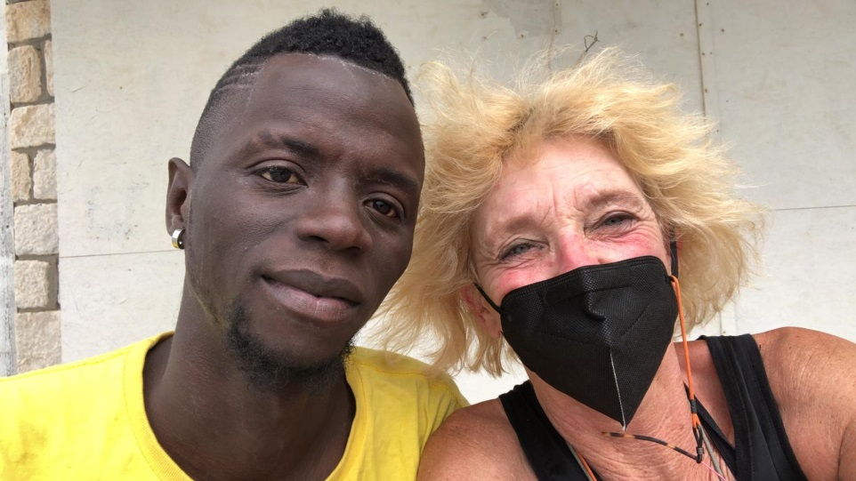

Nice coincidence: just as the Team was handing out the credit slips, Ingeborg Beugel arrived in the camp to witness the result of het Xmas call for support.
After nice contact with Simone, Dutch volunteer working with Armonia (restaurant for the vulnerable), Khalid has found a way to go to Samos, as a volunteer.

I wonder now how to proceed. Charity is not our thing, connectivity! Creative exchange and action, direct contact is a starting point. I would like to see closer contact between people in the camp and on the move and people in Holland.
The right tool for online meetings still has to be found, especially since most campers have pretty bad mobile phone. And is crypto art part of the solution?

PC4R in the UK could be a potential partner, for the charity angle. We still need to talk with them.

Jo M2M, 5 mei 2021

